**PROJECT DOCUMENTATION**

**U-Care**

**(The University Care)**

Complaint Management System for University Students



**Group No-01**

**IT3162-Group Project**

**Department of Physical Science**

**Faculty of Applied Science**

**University of Vavuniya**

**2022**

**DECLARATION**

We hereby declare that this report submitted for evaluation of the course module IT3162 leading to the award of Bachelor of Information Technology is entirely our own work, and the contents taken from the work of others has been cited and acknowledged within the text. This report has not been submitted for any other degree in this university or any other institution.

**Project Title:** U-Care (Complaint management system for University Students)

**Group Number:** 01

**Group Details:**

|  |  |  |
| --- | --- | --- |
| **Reg. No** | **Name** | **Signature** |
| 2017/ICT/17 | Ms. M.N.Fathima Sasna |  |
| 2017/ICT/44 | Ms. H.G.S.I.Dias |  |
| 2017/ICT/53 | Ms. T.Keethamy |  |
| 2017/ICT/58 | Ms. J.Sano Nas-hath |  |
| 2017/ICT/74 | Mr. S.Sabananthan |  |
| 2017/ICT/86 | Ms. V.Tharanika |  |

**I hereby certify that I have supervised this project.**

………………………………………………… .………………………

Mrs.Yasotha Ram Ramanan Date

Senior Lecturer,

Department of Physical Science,

Faculty of Applied Science.

………………………………………………… ………………………

Dr.S.Kirushanth. Date

Head,

Department of Physical Science,

Faculty of Applied Science.

**ABSTRACT**

Nowadays the university students are facing many problems. There are so many reasons for these problems such as, economical background, politics, country situation, covid-19 etc. So, they need a peaceful environment to study and travel university period.

Online Complaint Management System provides an online way of solving the problems faced by the students by saving time and eradicate corruption. The objective of the complaints management system is to make complaints easier to coordinate, monitor, track and resolve, and to provide university with an effective tool to identify and target problem areas, monitor complaints handling performance and make education improvements. Online Complaint Management is a management technique for assessing, analyzing and responding to student’s complaints. Complaints management software is used to record resolve and respond to student’s complaints, requests as well as facilitate any other feedback.

**ACKNOWLEDGEMENT**

We owe a great thanks to many people who helped and supported us during the designing and completing our project as well as writing of this report also.

We extend our sincere thanks to our esteemed guide Mrs.Yasotha Ram Ramanan for providing us with the right guidance and advice at the crucial junctures and for showing us the right way by supporting us to complete each milestone of our project from the beginning to the end.

We extend our sincere thanks to our respected Head of Department of Physical Science Mr. Sivaramalingam Kirushanth, for allowing us to use the facilities available.

We would like to thank the other faculty members also, at this occasion. Last but not the least, we would like to thank friends for the support and encouragement they have given us during the course of our work towards the success.

**Thank You…!**

**CONTENTS**

**Part I**

BACKGROUND…………………………………………………………………………………………………………05

AIM OF THE PROJECT………………………………………………………………………………………………05

PROBLEM STATEMENTS………………………………………………………………………………………….06

OBJECTIVES……………………………………………………………………………………………………………..06

SCOPE……………………………………………………………………………………………………………………..06

LIMITATIONS…………………………………………………………………………………………………………..07

**Part II**

OVERVIEW………………………………………………………………………………………………………………07

EXISTING SYSTEMS………………………………………………………………………………………………….08

PROPOSED SYSTEM…………………………………………………………………………………………………12

TOOLS AND TECHNICS…………………………………………………………………………………………….13

**Part III**

METHODOLOGY………………………………………………………………………………………………………14

**Part IV**

DESIGN AND IMPLEMENTATION……………………………………………………………………………..16

**Part V**

USER EVALUATION………………………………………………………………………………………………….29

TESTING………………………………………………………………………………………………………………….30

TEST REPORTS…………………………………………………………………………………………………………35

**Part VI**

CONCLUSION…………………………………………………………………………………………………………..36

FUTURE IDEAS…………………………………………………………………………………………………………37

**Part VII**

REFERENCES……………………………………………………………………………………………………………37

# BACKGROUND

Design and implementation of the web application is to maintain an effective, timely, and equitable complaint handling system which is easily accessible and offered to complainants at no charge.

This project defines the policy and steps for handling and resolving complaints and also to appeal for an un-favored situation and for this process to take place there must be an automation of the system that will handle the complaints process and appeal method of registration. Automation can be defined as the aspects involved in using a computer system for the tasks or process such as circulation, implementation etc.

In the university life, students and Staffs are facing so many problems. But sometimes they may not execute those problems to the appropriate person or committee because, they have a fear to tell their statements against high level staff and unable to go to the related committee to explain those problems. So, the project will minimize the troubles of conveying it to outsiders.

Therefore, this project is to develop this university complaint Management System for students and Staffs at the University Level, when they spent few minutes, they can submit their problems via mobile or any networked Devices.

# AIM OF THE PROJECT

The ultimate objective of this project is to provide cost effective, reliable, user-friendly computerized system for a student of a university. This system can be modified and changed according to new technologies and for new requirements. So that, any of the Sri Lankan university can use this system with their requirements. The fundamental requirements can be added to this system.

Objectives of this online complaint management system are as follow:

• To develop a student complaint management system which will help in managing complaints or applications received from university students.

• Identify how to handle student complaints.

• expediate the process of complaints of university students.

• Increase the level of university student’s care.

• Reliable method of complaining.

• To make complaints easier to coordinate, monitor, track and resolve.

# PROBLEM STATEMENTS

A large university may face a slew of issues due to an overabundance of students. The most common are listed here:

* A student needs to get a permission to convey their problems manually to the responsible persons (authority and staffs).
* When get permission student need to explain their problems manually, at the movement student faced some fear to convey all the problems.
* Sometimes student’s representatives and union members only can get permission to meet higher authority so normal student can’t get opportunity to meet them.
* This is a time-consuming process and the accuracy of the details are doubtable.
* Authority plays a very stressful role in this manual process.

# OBJECTIVES

* To develop a University Complaint Management System which will help in managing complaints or applications received from university students.
* Identify how to handle student complaints.
* Fast processing of complaints of university students.
* Increase the level of university student’s care.
* Reliable method of complaining.
* To make complaints easier to coordinate, monitor, track and resolve.

# Scope

The scope is important to set a boundary on what the area will cover in the application development. Thus U-care Web Application is focused on online in Sri Lanka. Scope of this system is University Admin Staffs & Students.

### **Student**

* Login & Signup
* Manage Profile
* Lodge Complaint
* View Complaints

### **Admin**

* Login
* Manage Profile
* Manage Complaints
* Manage User
* Add Categories
* Add Sub-Categories

# 

# LIMITATIONS

* There are some limitations in the web application.
* Only admin and user can view the complaint.
* A student and staff can register only one account.
* A response will be provided to the person who made the complaint within a specified time period.
* These complaints will be handled by a particular staff member or in-charge or team of members who are assigned to the task specified.

# OVERVIEW

This document provides a brief introduction of the software requirements of the system, a description of the overall system, some user requirements and the interaction between the user and the system and, describes the functional and interface requirements in detail

# EXISTING SYSTEMS

1. **Complaint System of Peradeniya University**

Complaint System URL: [*https://www.pdn.ac.lk/Complaints/complaints.php*](https://www.pdn.ac.lk/Complaints/complaints.php)

Ensures that the identities of those who wish to file a complaint are strictly protected in here. And also, only the Vice Chancellor and the Chairperson of the sexual and gender- based harassment and sexual violence Monitoring Committee can access the complaint and identify the complainant’s identity.

Required fields are marked in this complaint system. They are Email Address, Faculty or Division, are you a victim If not, what is your relationship to the victims Identify the parties to this incident and Message. And also Providing other fields are not essential.

In here, it is important to pay attention to the following things in order to provide a fair and speedy solution.

* To identify the mental state of the person who has come to lodge a complaint and to identify whether the person is responding quickly or to respond in a formal manner and to provide the person with the necessary psychological counseling and expert advice.
* In case of any harassment or video being socialized or it is severely debilitating, the

person who comes to lodge the complaint should be properly informed and remedied

and the person should be assisted by a woman or a man.

But there are some drawbacks in this system.

* In here Providing an opportunity for a person to confirm their complaint via personal email will allow everyone to know their personal emails. This is a drawback in here.

**As a solution** this drawback, that a portal can be set up so that the person can make a complaint through a temporary account at that time.

* The University of Peradeniya complaint system has only one application for all the Complaints but some complainants need to do not like share their private details.

**As a solution** to this, we can submit two forms. Here one is for top secret complaints and

the other is for general complaints. So, the person has a choice based on its status. Also,

in the top-secret complaint’s form only, the relevant complaint can be mentioned

without mentioning our personal details.

1. **Pakistan citizen portal**

Prime Minister’s Performance Delivery Unit (PMDU) established in 2013 has been reorganized with a new vision to promote citizen-centric and participatory governance.

PMDU is pioneering a nation-wide complaints and grievance redressal mechanism with special emphasis on facilitation of overseas Pakistanis, women, special persons and foreigners. The primary objective of the unit is to provide citizen’s an opportunity to seamlessly communicate with all government entities and have their issues resolved with priority, in accordance with the vision of the Government.

The Unit will enable the establishment of a culture of quantified performance management and make the various government entities accountable for their mandated roles and responsibilities. Besides, the Unit will put forward recommendations for amendment and simplification of cumbersome official procedures as evidenced from the database for the purpose of assuring public facilitation.

The Unit strives to assure that the registered citizens/members on Pakistan Citizen’s Portal (PCP) get every possible relief from the Government Organizations being interacted. The citizens/members may have suggestions to put before the authorities or personal complaints and grievances or to report violations of laws by the people or to seek guidance etc.

The Unit takes it as a prime responsibility to ensure that all complaints and suggestions are handled fairly and efficiently through concerned organizations. This manual is designed to help the Government Organizations to efficiently respond to the matters raised on the Portal. The processes described in this manual are intended for understanding and use of all concerned stakeholders.

1. **Jansunwai**

For registering, tracking, send reminder & amp; giving feedback citizen’s grievances

Uttar Pradesh Government has launched the mobile App for registering citizen’s grievances/suggestions. The Mobile App is linked to the Jansunwai (IGRS) portal of Uttar Pradesh Government, where grievances/suggestions can also be registered through Web (jansunwai.up.nic.in). A fast and user-friendly interface has been provided for

registering and tracking of grievance through mobile phones. Each Grievance will be provided a unique Reference number. Citizen can use this reference number to track progress of grievances, send reminder & also for giving feedback after disposal. After successful registration, the reference will be automatically forwarded to the concerned officer for redressal.

1. **Foreign minister portal**

Complaint Management System for foreign Pakistani Nationals

‘FM PORTAL” works as a Complaint Management System which helps in resolving queries and concerns of Overseas Pakistanis and Foreign Nationals living abroad. The official serviceability and technology owner is National Information Technology Board (NITB). The application is officially developed, designed and managed by the National Information Technology Board (NITB), commissioned by the Ministry of Information technology & Telecom (MoITT).

Features:

• Easy to use

• User-friendly

• Resolves complaints and concerns

• Welcome feedback

1. **National Consumer Helpline**

This Mobile App is an alternate way to register consumer related grievances in the portal

URL: <https://consumerhelpline.gov.in/>.

The website was launched by the Department of Consumer Affairs to create awareness, advise and redress consumer grievances and act as a central registry for lodging consumer grievances. Though all efforts will be made to address grievances made on the portal, if the grievance is not redressed to the full satisfaction, a consumer has choice to approach the appropriate Consumer Fora.

An aggrieved consumer can register grievance by either calling the toll-free number 1800-11-4000 or 14404 to talk to an agent to register or register online on the portal or through the Mobile App in which case the consumer gets a user id and password to lodge grievance. On the portal or through Mobile App,

**Step 01-** For onetime registration, consumer is required to click on the signup giving details required and verifies through his/her email. The User id and password are created.

**Step 02-** Using this user id and password, consumer enters into the portal and fills in required details of grievance attaching necessary documents (if available).

This Mobile App has the following additional features: -

(a) consumer awareness material under the link Consumer Knowledge Base.

(b) Addresses of various Consumer Fora are also available under the link Consumer

Forum Contact Details.

(c) Various useful sites are linked under Important Links.

Any grievance received entered in the portal and a unique docket number is generated and given. Grievances received are sent to the concerned company / agency / regulator / ombudsman, as the case maybe, for speedy redress. Action taken is updated on real time basis by the concerned agency. As a follow up action, these agencies are reminded at stipulated interval.

The status of the complaint can be tracked through the Mobile App under the link “Track your complaint”. Status of complaints are also communicated via automated emails.

1. **Wafaqi mohtasib cmis**

App allows to lodge their complaints against Pak. federal government agencies.

This App connects general public with the Wafaqi Mohtasib Secretariat and allows them to lodge their complaints against federal government agencies. The list of agencies is provided in the App. The complaint is registered online and becomes part of the Complaint Management Information System of the Wafaqi Mohtsib.

You will receive an SMS within minutes of lodging a complaint which will confirm the registration of complaint. You can select either head office (Islamabad) or any regional offices (Lahore, Karachi, Peshawar, Quetta, Hyderabad, Sukkur, D.I. Khan, Abbottabad, Bahawalpur, Multan, Faisalabad, Gujranwala and Faisalabad) nearest to you and your case will be heard at the selected station. The App shows the status of your case at each stage, and on conclusion of hearing, you can also view or download finding of the Wafaqi Mohtasib in your case. For any assistance, please call helpline 1055 between 9:00 AM to 10:00 PM(PST) or visit this website www.mohtasib.gov.pk. Children or on behalf of children, complaint on any children issue can also be filed with this App.

# PROPOSED SYSTEM

The university system has students complains by collecting method manually such as suggestion box in a particular place to develop the student's environment. But this is not a reliable method to find all problems faced by students.

Now, we all are facing the covid-19 situation, and located in distanced places. With the distanced learning and distanced management, we put a solution to detect the problems among the students of Vavuniya University. So, we planned to make a web application to collect all the problems of students. Which the complaint, can be posted at any place and any time. So, this application can help to our University Management System to find and resolve all the problems of students peacefully and make the University environment user friendly for the students.

* Students can complain to
  + Students’ Union or Student representative of Faculty Board or to complaints management team of University of Vavuniya.
  + against to a student, staff and other university related problems
  + privately or publicly.
  + Regarding Ragging, Lectures, Canteen, Wash room facilities and other providing facilities by the University
  + with evidence by Attaching it (such as image, audio, video).

# **TOOLS AND TECHNICS**

The front end is designed using HTML, CSS, JavaScript.

The back end is designed using PHP, MYSQL.

**Software Requirements**

|  |  |
| --- | --- |
| **Software** | **Purpose** |
| VS Code | Type & Edit Code |
| XAMPP Server | Host the Application as a Server |
| Spring Boot | Frame Work – Create Database |
| Google Chrome | Handling Database (PhpMyAdmin) |
| Adobe XD | Design Wireframes & Prototypes |
| Draw.io | Create Context Diagrams & Data Flow Diagrams |
| Microsoft Office Word 2021 | Prepare Documentation Report |

**Hardware Requirements**

|  |  |
| --- | --- |
| **Hardware** | **Type** |
| Laptops | Operating System: Windows 11 Home  Processor: Intel(R) Core (TM) i3-7500U  Installed memory (RAM): 8.00GB  System Type: 64-bit Operating System |

**Users of the System**

•Students

•Students’ Union Members

•Student Representatives

**Admin Side of the System**

•Complaints management team

•Operator

•Database Admin

•Student Counselor

# **METHODOLOGY**

**Introduction**

The methodology is the set of the complete guideline that includes the models of tools to carry out activities in the Software Development Life Cycle (SDLC). SDLC splits the work into phases of activity for better planning and management of the system development.

**Spiral Model**

The methodology that will be used in U-Care is Spiral Model. Spiral model is a combination of sequential and prototype model. There are specific activities that are done in one iteration which is spiral where the output is the small prototype of the large software. Thus, the same activities are repeated for all the spirals until the whole software is built. There are six phases involved in the spiral model which is requirement Gathering phase, planning phase, design & implementation phase, testing phase, deployment and evaluation phase.

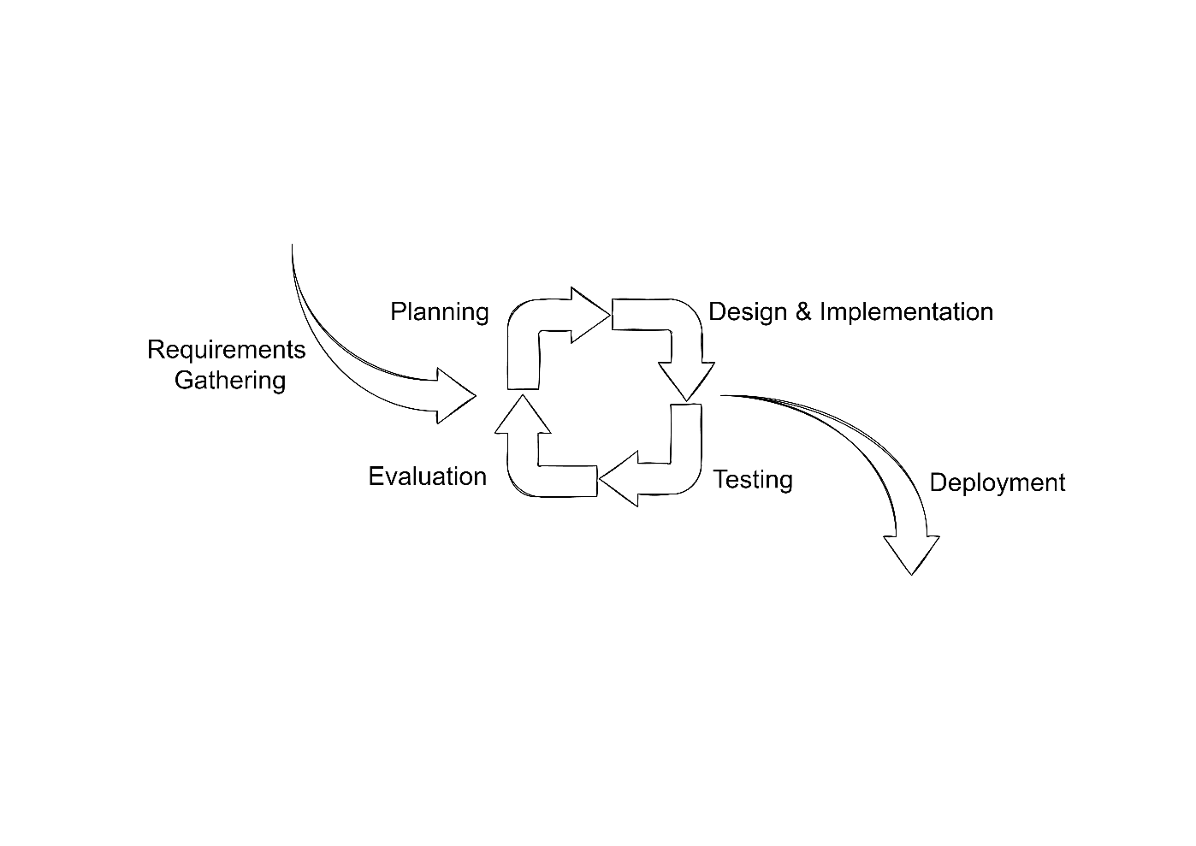

**Spiral Model (SDLC MODEL)**

**Methodology Phase**

The explanation of each phase involves for developing U-Care is below:

1. **Requirement Gathering Phase**

At this phase, the process occurred is brainstorming the project idea and proposed the title of the project. Then, U-Care was decided. objectives of the system are identified and all the requirements are gathered in order to develop the system.

1. **Planning Phase**

Planning phase is the most important phase as a guideline to develop the system. During this phase, Research for the system is being allocated and designing a schedule to ensure that the system follow the timeline made. Research for the system is made by reading articles and journals related to the system and the method used. System scheduling is created using a Gantt chart to ensure that the system will develop systematically and to make sure the project can be done on time. In planning phase also getting the user requirement by observation from user in Vavuniya University to meet the functionality requirement of the system that will develop.

1. **Design & Implementation Phase**

During this phase, some research has been done through articles and journals. The best approach and added value in U-Care. Consequently, more research works have been studied to further understand the theory and how the technique can be applied in the system. All of the disadvantages of the system are listed and come out with the solution in developing this system. Methodology, techniques, hardware and software requirements are also analyzed in this phase. This is to ensure that every requirement and any related things need to be done are suitable with the system. Design phase of the system is done based on the output produced during analysis phase.

First, all the required hardware and software requirements for the proposed system are working properly. Design Entity Relationship Diagram (ERD) to translate the process flow of the U-Care. Interface and database designed based on the requirements stated analysis during this phase. Then the working prototype designed to get another further improvement to be added into the proposed system.

Then, all activities that have been planned during phase before are executed. The system is developed using PHP, Visual Studio Code and MYSQL. Database and interface designed during design phase are started to be developed. The process of writing the coding is being done and the progress of the system are reported from time to time.

1. **Testing Phase**

When the system is fully developed, system is being tested. For this system, the black box testing and white box testing is used to test the correctness of the implementation coding and search for any errors and bug. If there are any errors, it must be rechecked and come out with the solution.

1. **Deployment and Evaluation Phase**

During this phase, the system is released to be used by the user. The users use the system and give their feedback whether it needs to be improved or there is anything that needs to be modify. Then the modifications are being made based on the feedback from the user to make sure the system is completely fulfilling the requirements.

# **DESIGN AND IMPLEMENTATION**

**Design**

System design is mainly focus on the design of the system which includes the ER diagrams, Process flow diagrams, user interface design etc. Designing the front end and the back end includes under this section.

**Use Case Diagram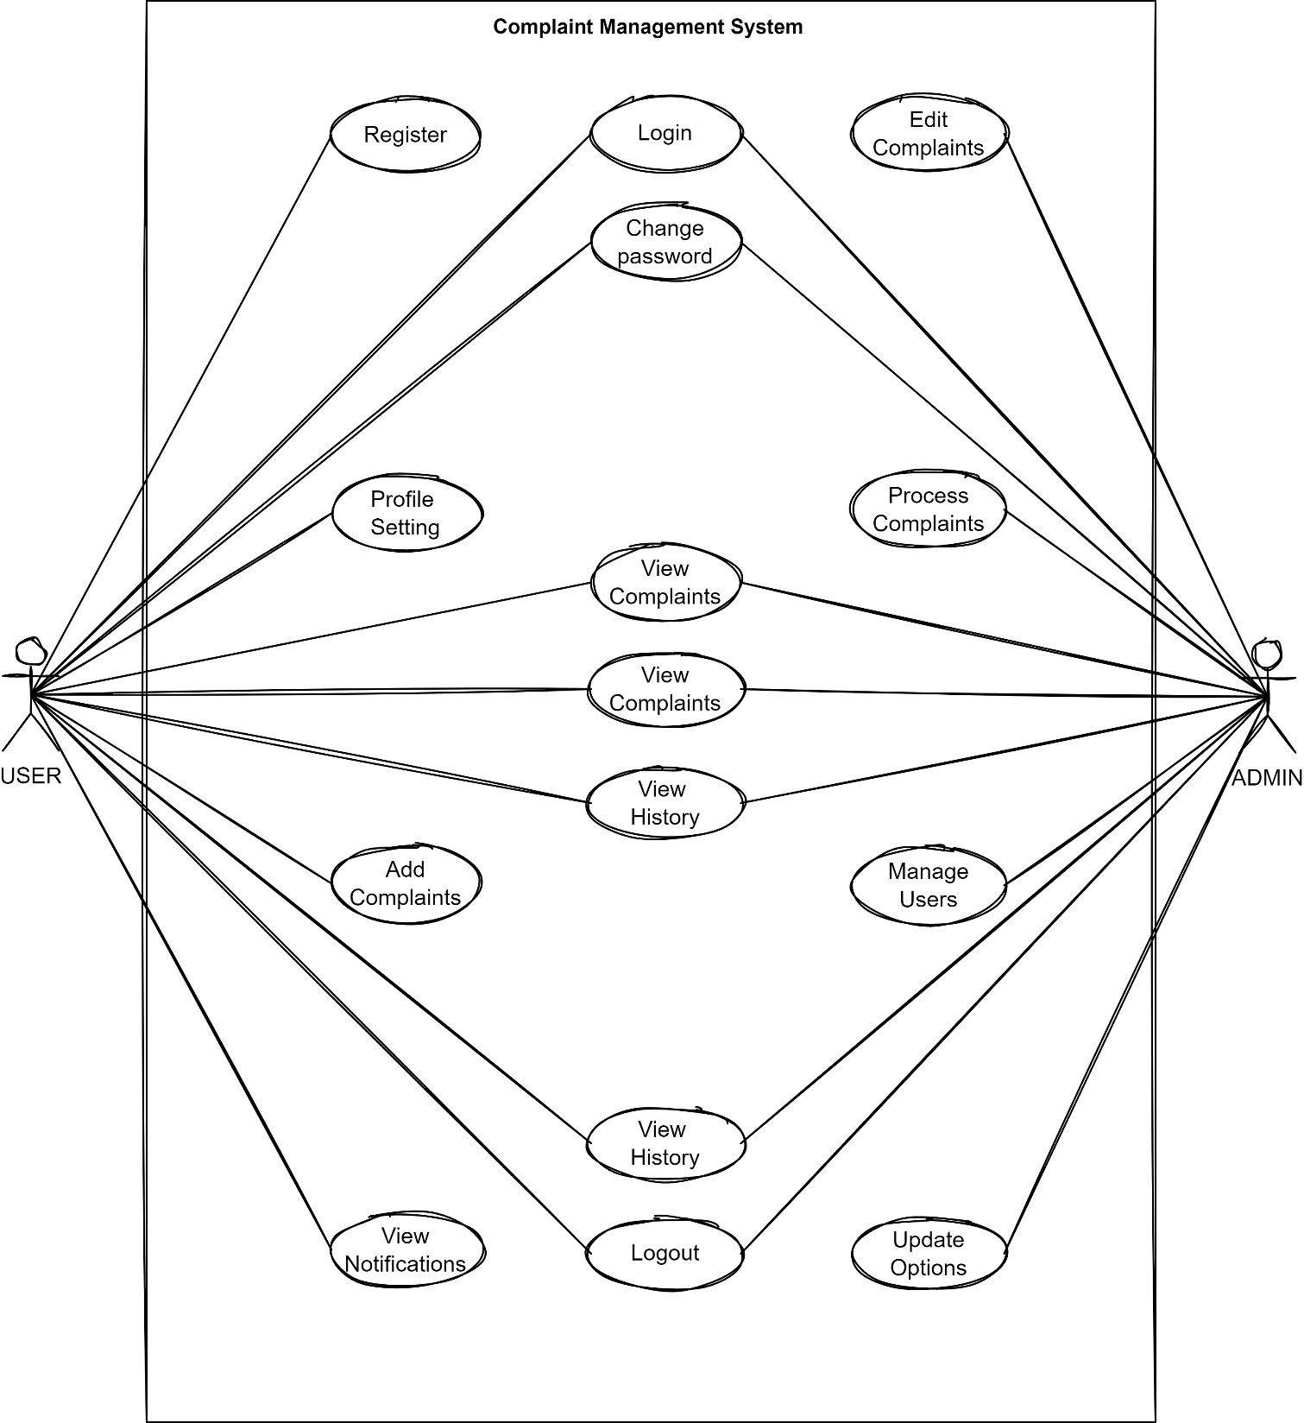:**

**Use Case Diagram**

**Process Flow Diagram:**

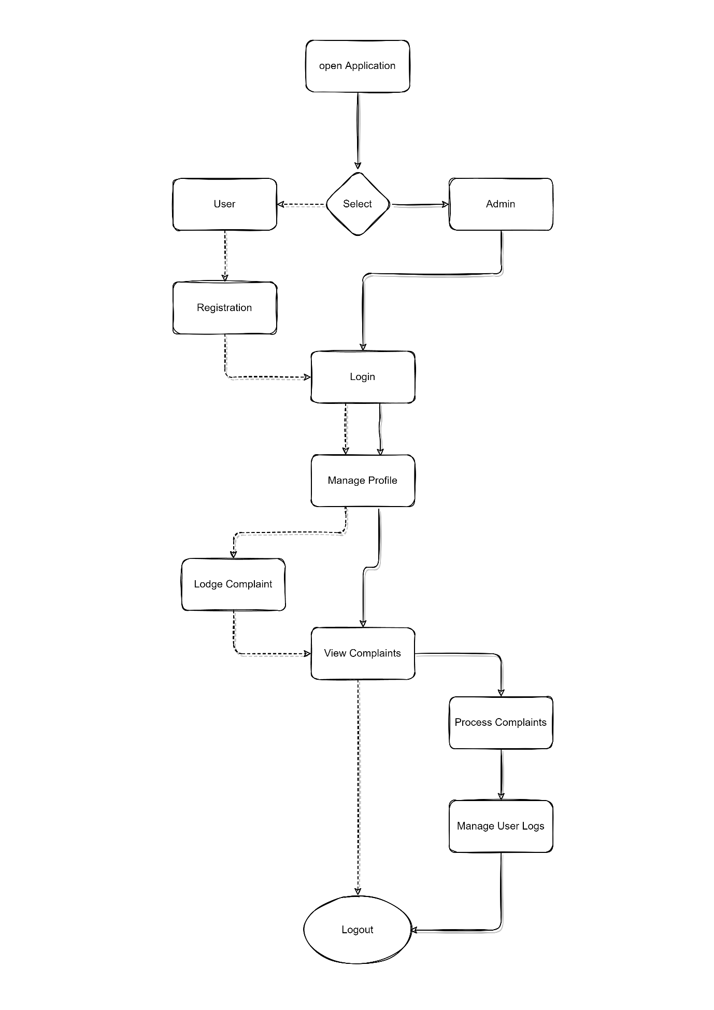

**Process Flow Diagram**

**• Software Architecture**

Software application architecture is the process of defining a structured solution that meets all of the technical and operational requirements, while optimizing common quality attributes such as performance, security, and manageability. It involves a series of decisions based on a wide range of factors, and each of these decisions can have considerable impact on the quality, performance, maintainability, and overall success of the application. The 3 tier - architecture for the reservation system is as follows.

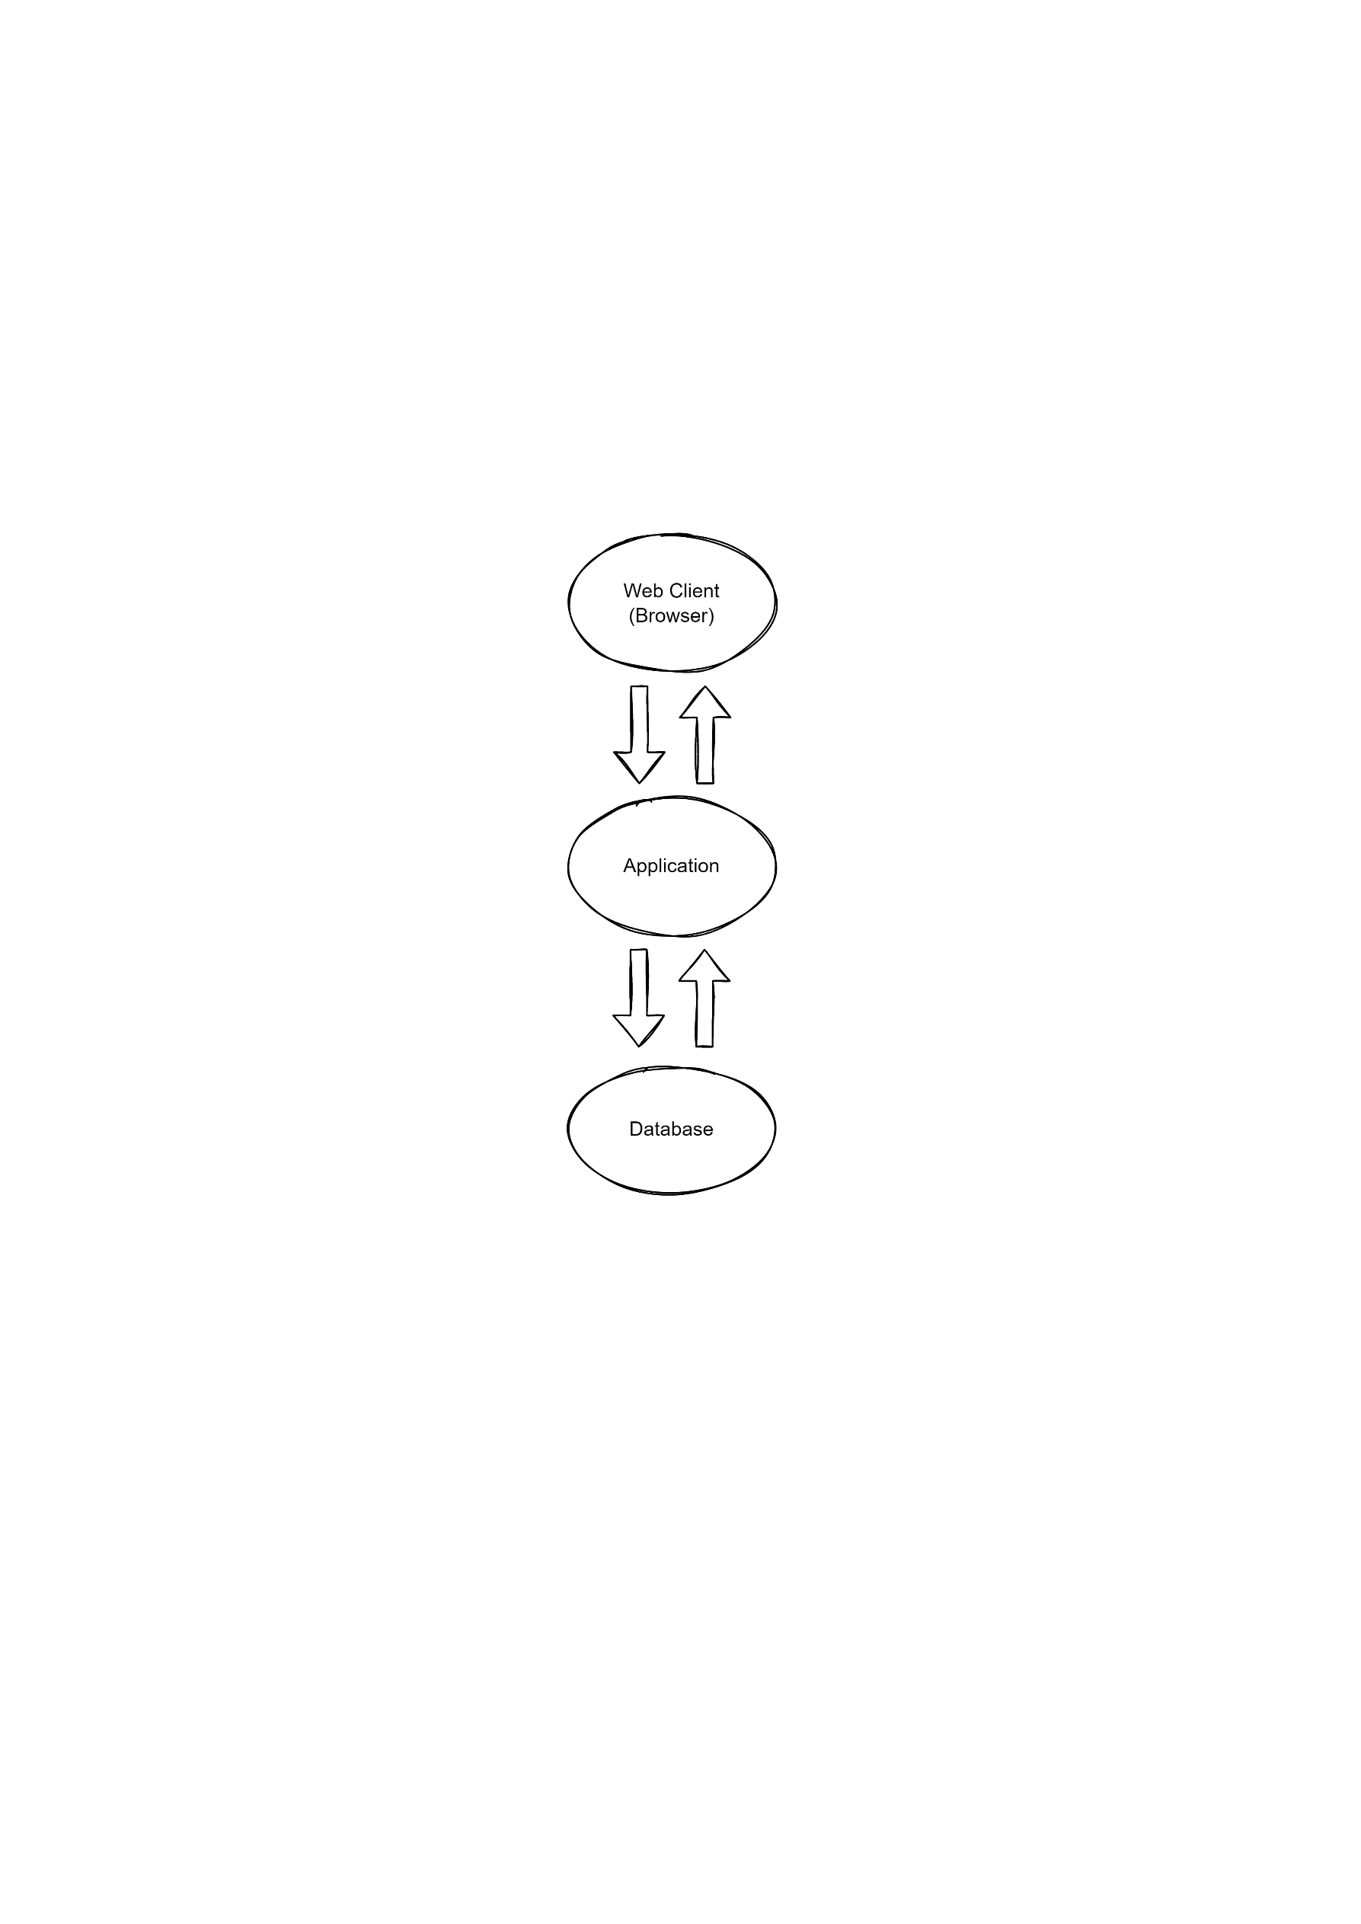

Three-tier Architecture

• **Database Design**

An Entity Relationship (ER) Diagram is a type of flowchart that illustrates how “entities” such as people, objects or concepts relate to each other within a system. ER Diagrams are most often used to design or debug relational databases in the fields of software engineering, education and research.

* Entities
* User - Properties of the user
* Admin - Properties of the admin

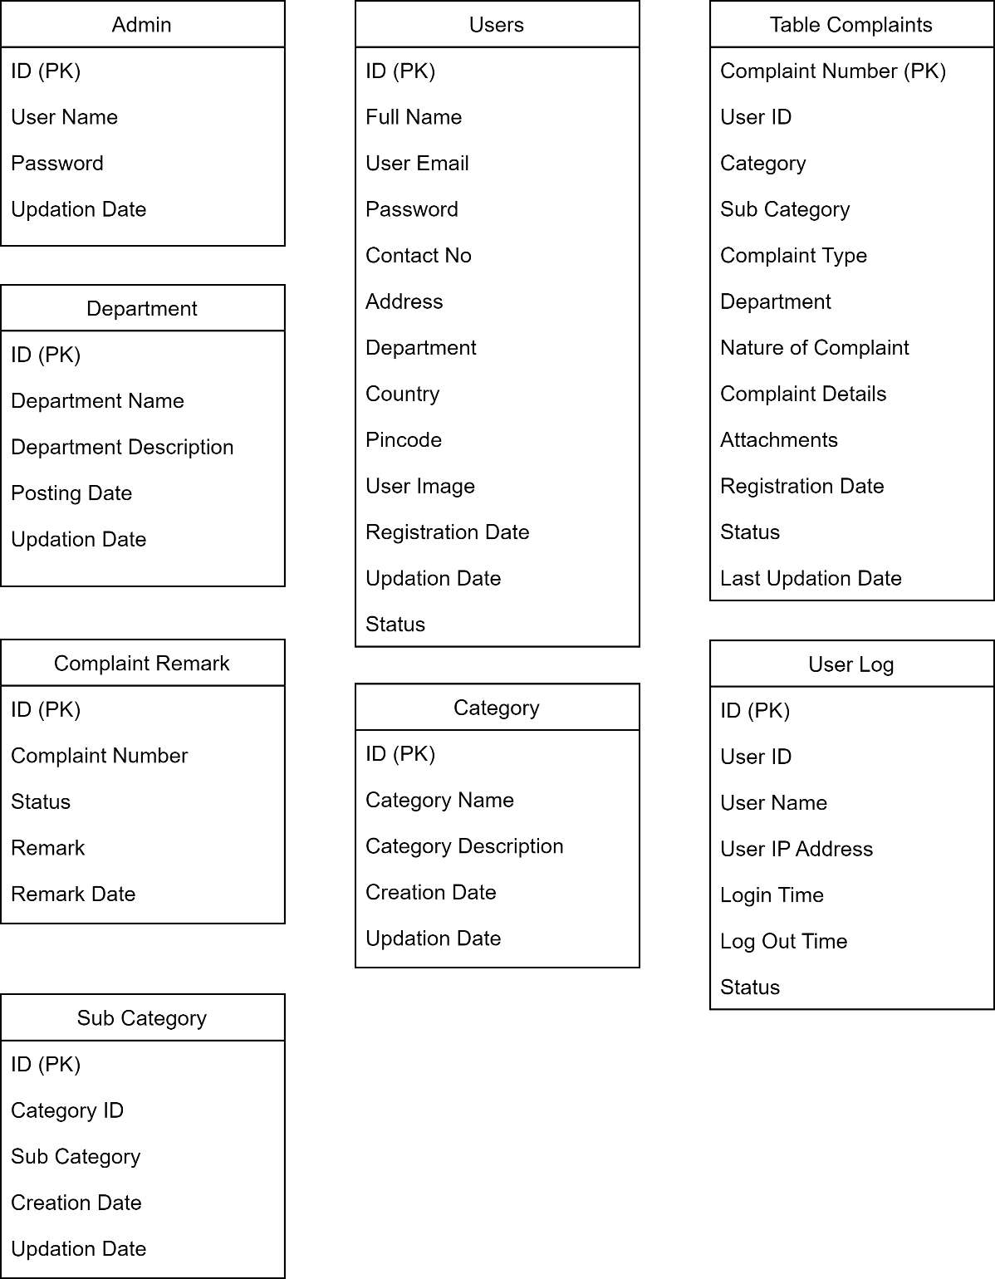

Class Diagram

**Implementation**

**• Interface layer**

The interface layer of this system is built using HTML and CSS style sheets.

1. Index page-01

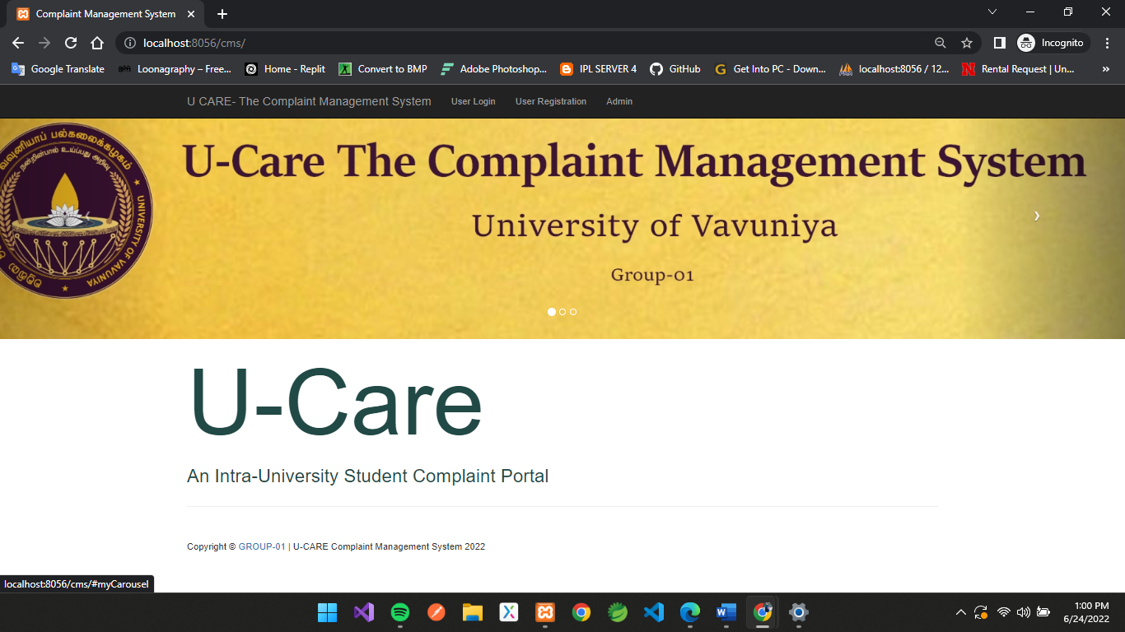

2. Index Page-02

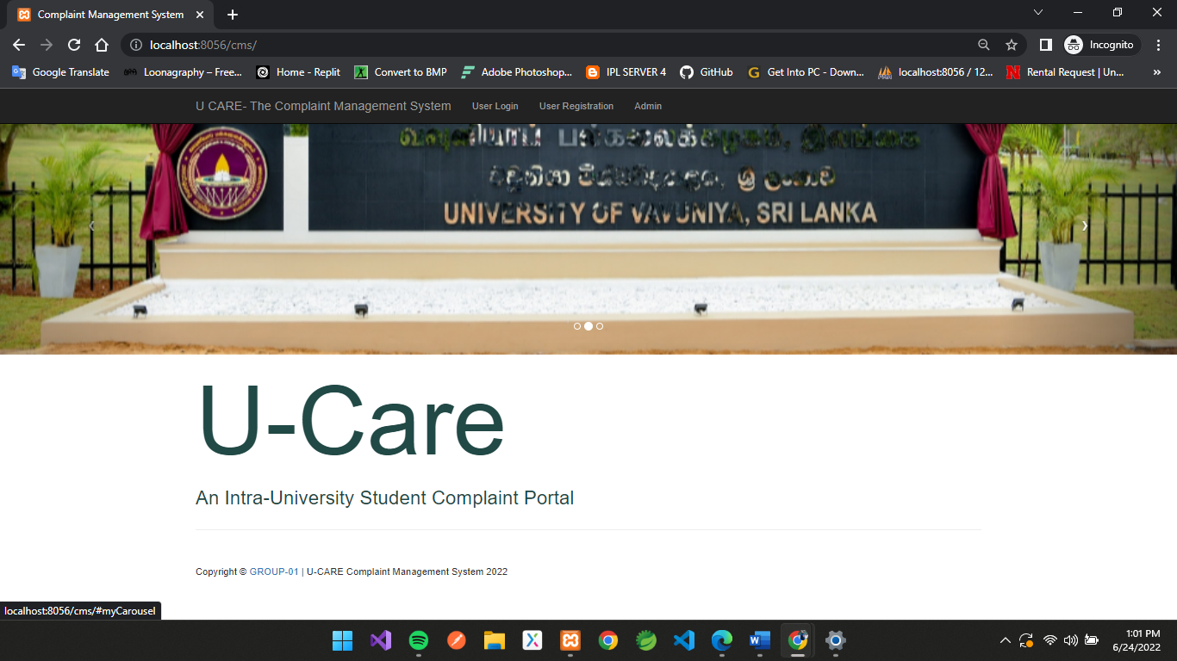

3. User Sign in Page

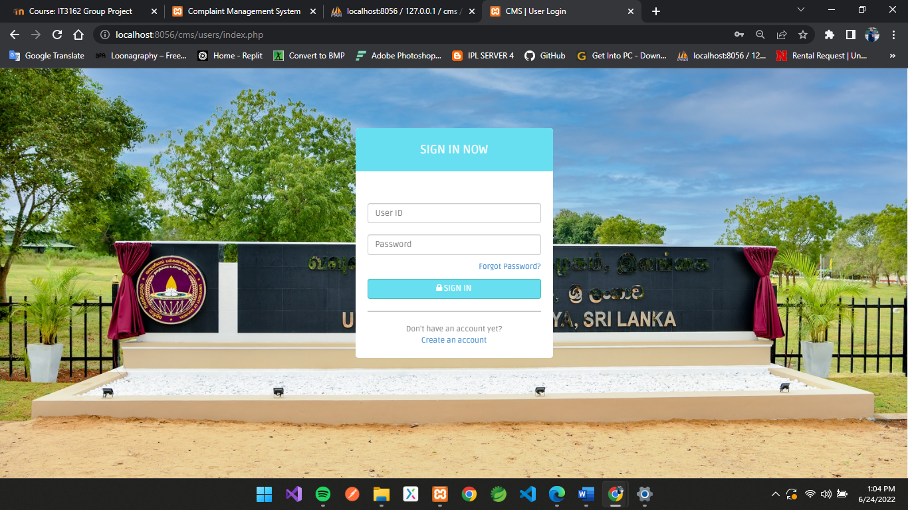

4. User Registration Page

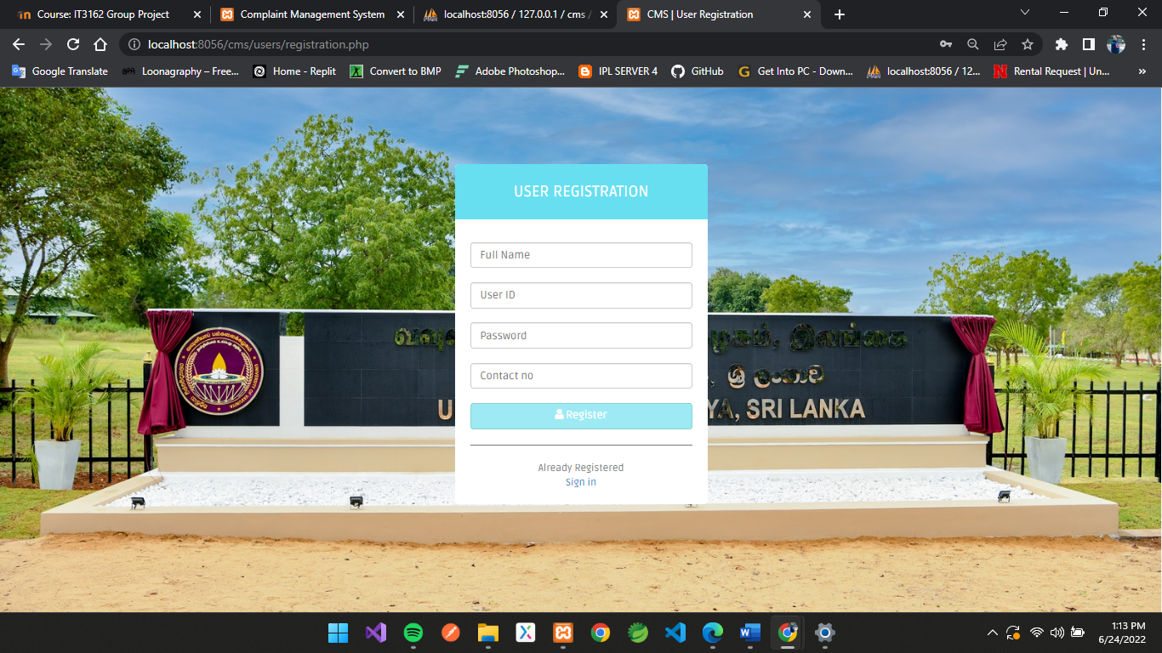

5. Dashboard (User)

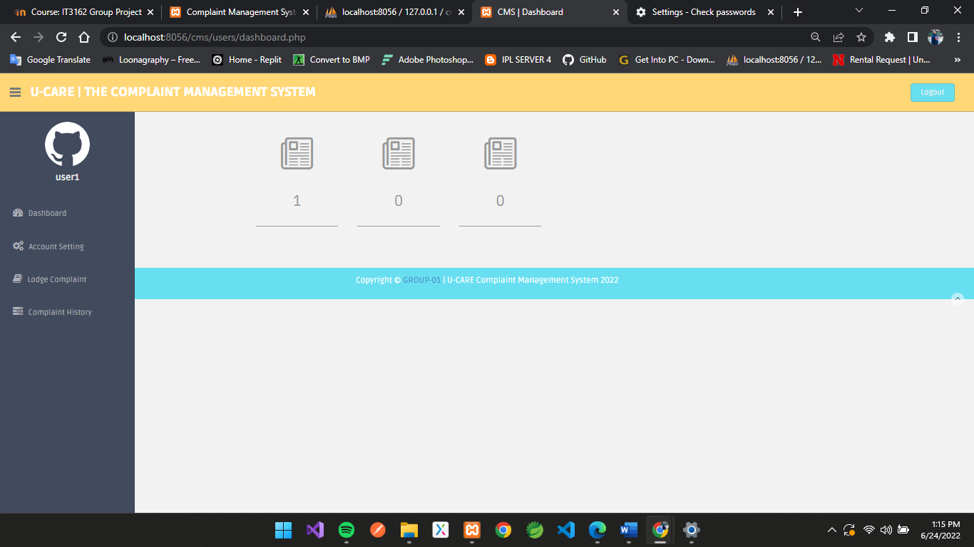

6. Account Setting (User)

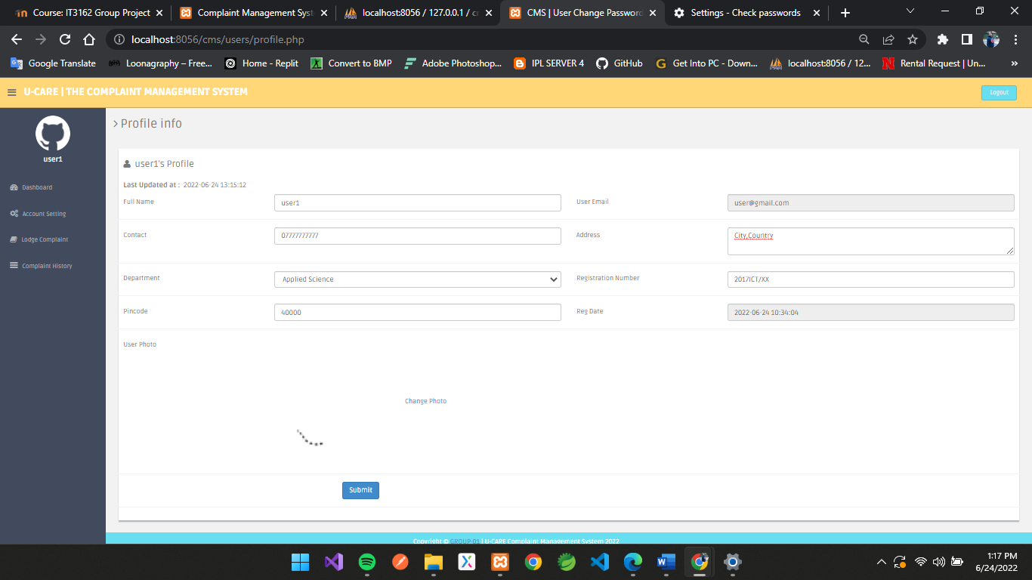

7. Change Password (User)

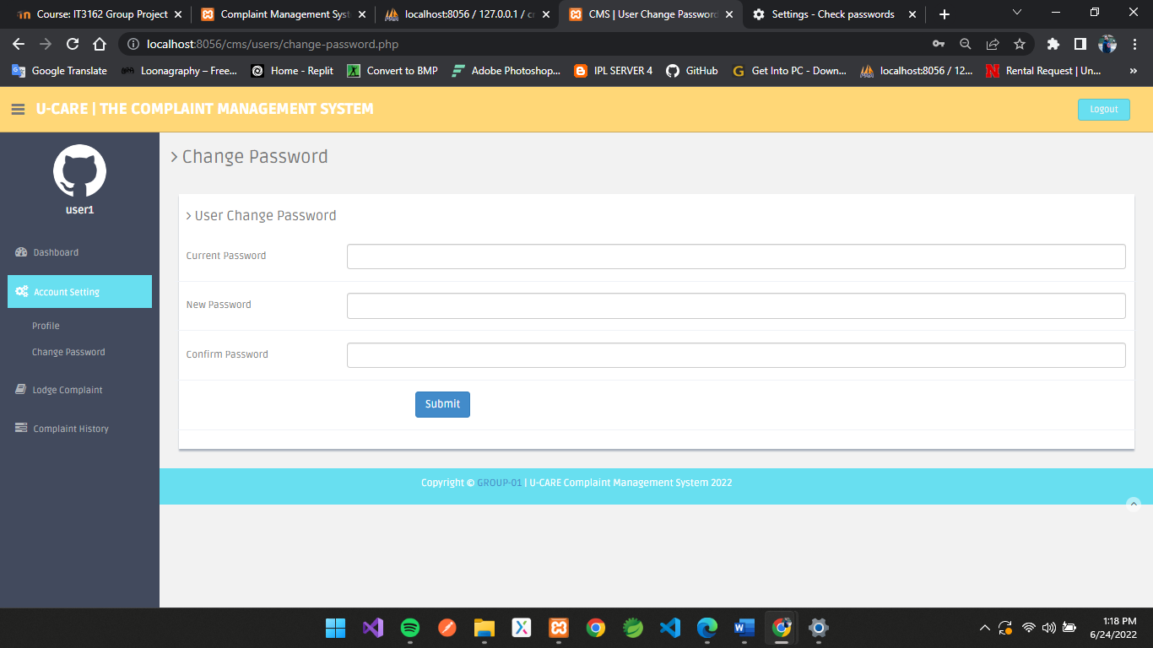

8. Lodge Complaint (User)

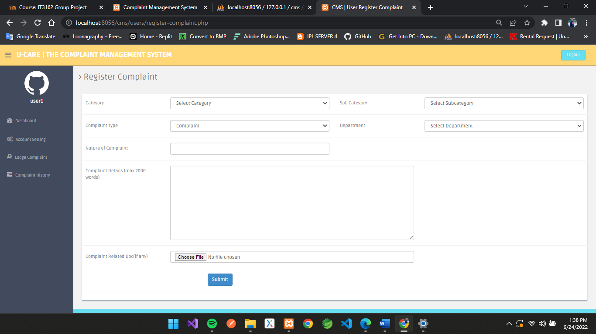

9. Complaint History

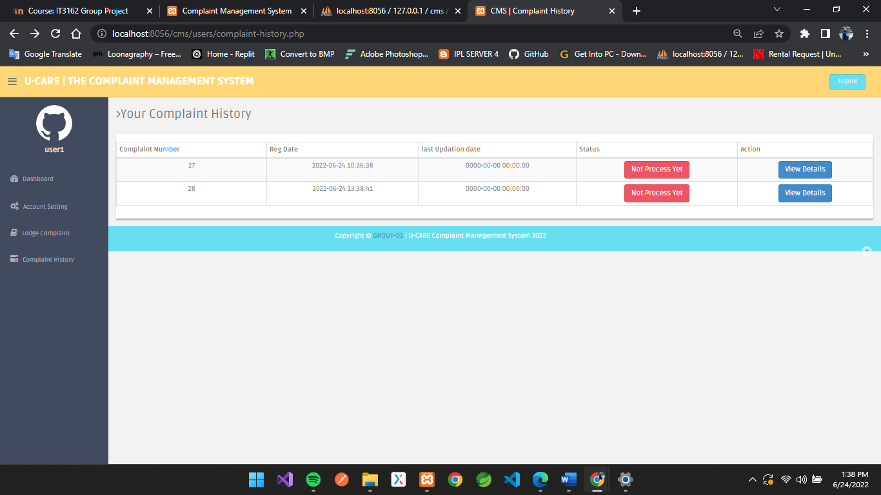

10. Sign In (Admin)

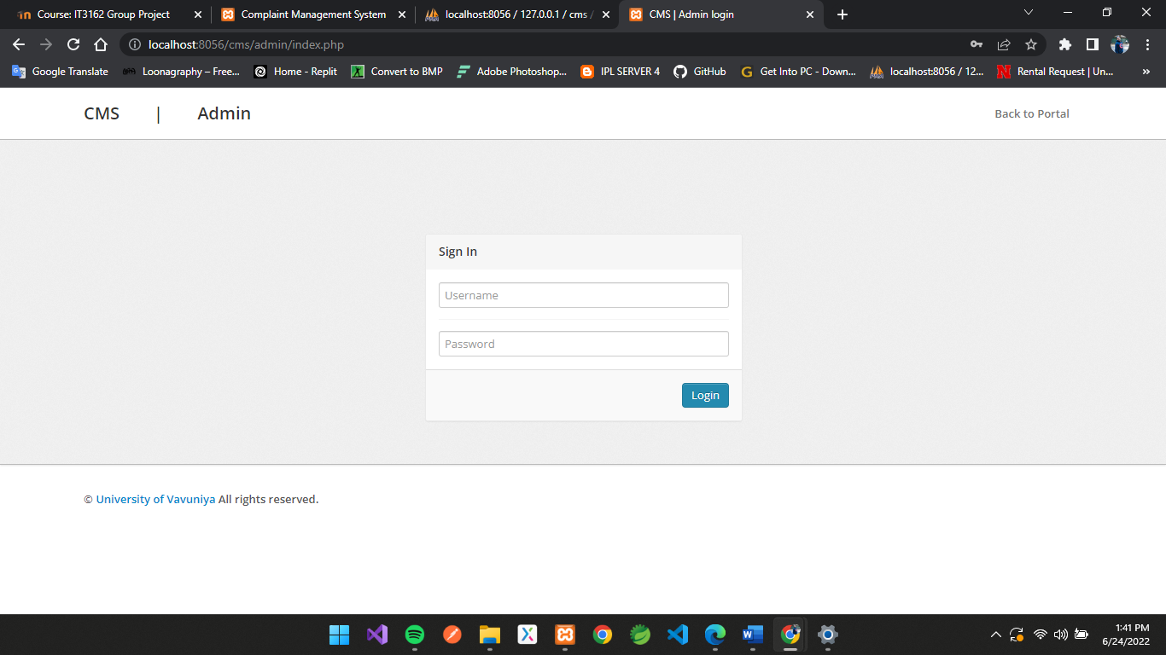

11. Change Password (Admin)

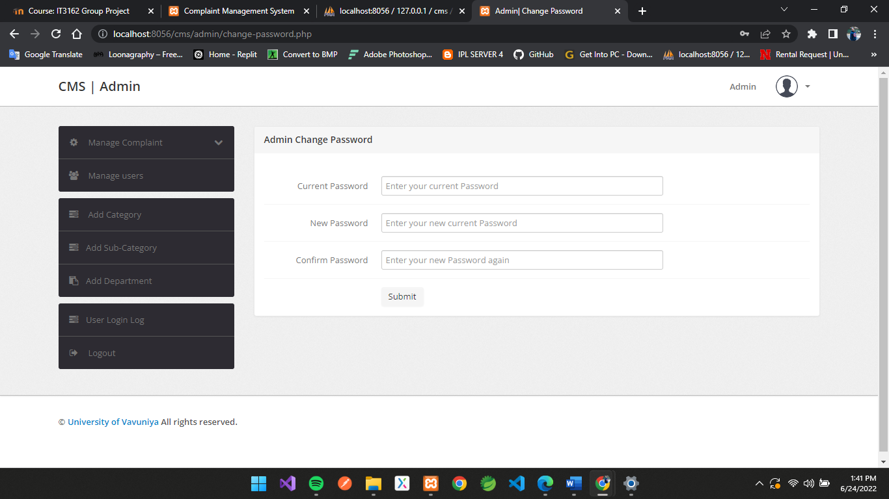

12. Manage Complaint (Admin)

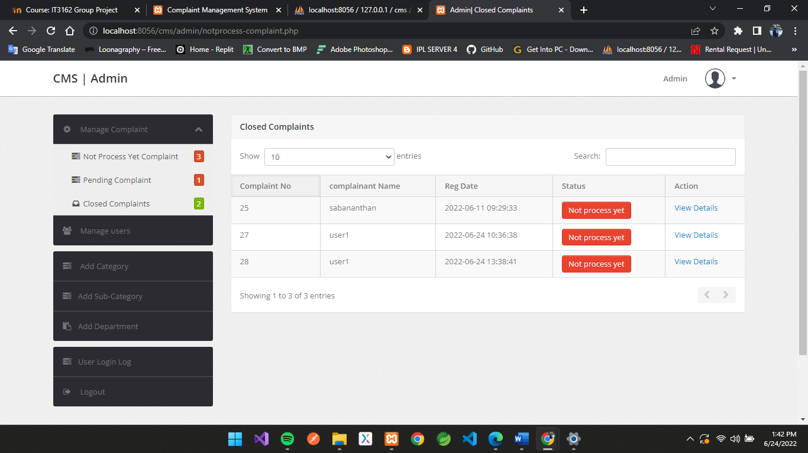

13. Manage Users (Admin)

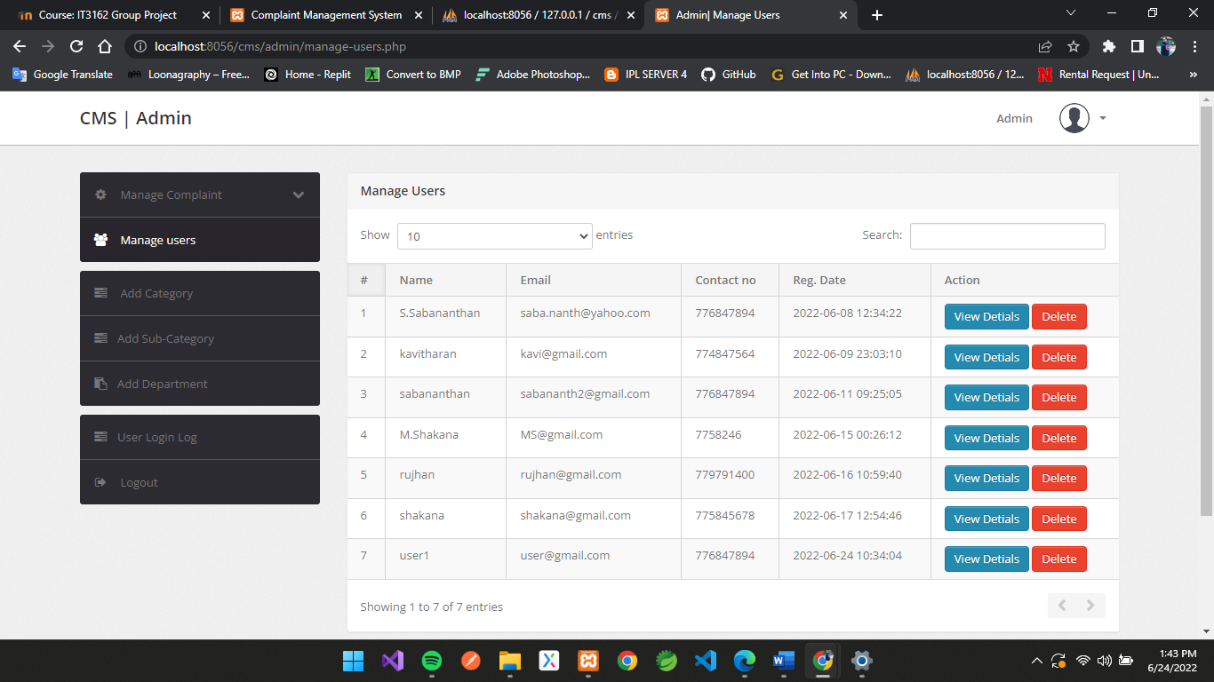

14. Add Category (Admin)

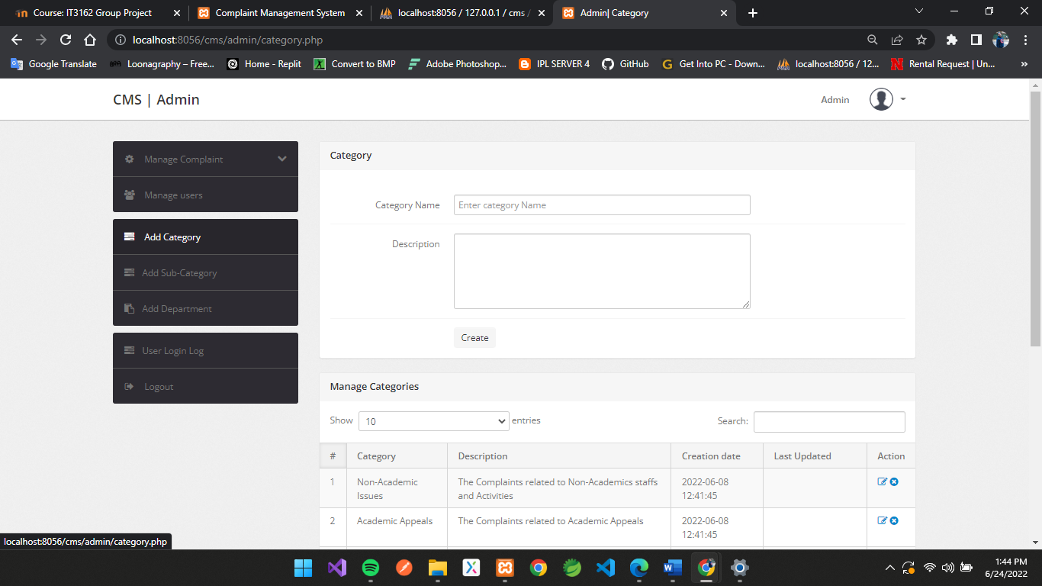

15. Add Sub Category (Admin)

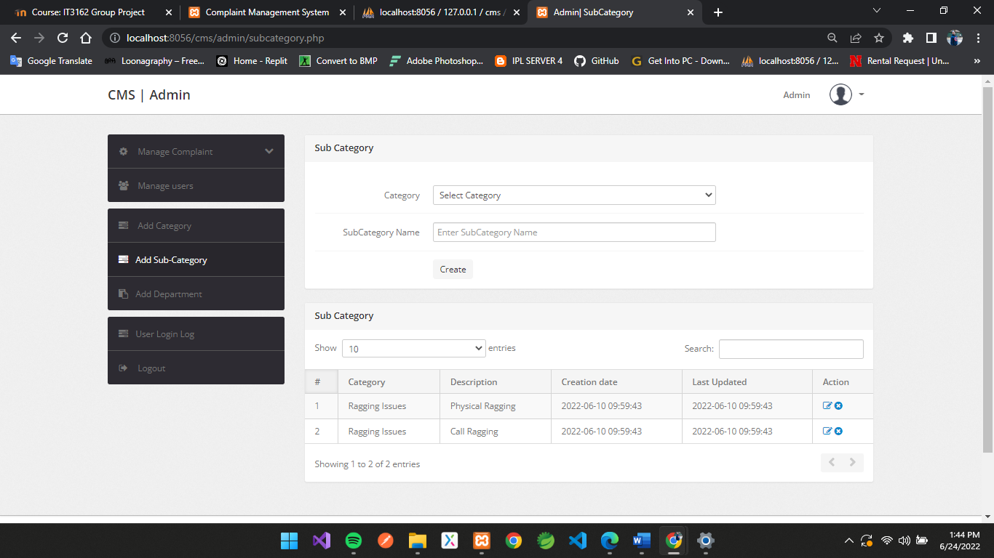

16. Add Recipient (Admin)

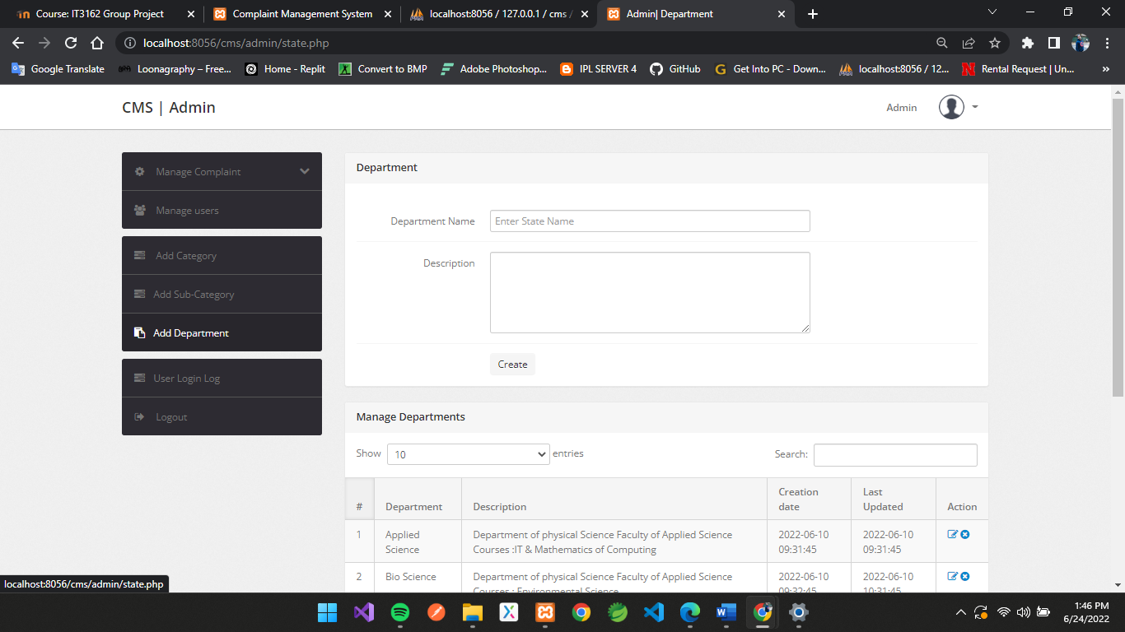

**•Data layer**

The data layer of this system is created using SQL server. The database has been modeled using an entity relationship diagram.

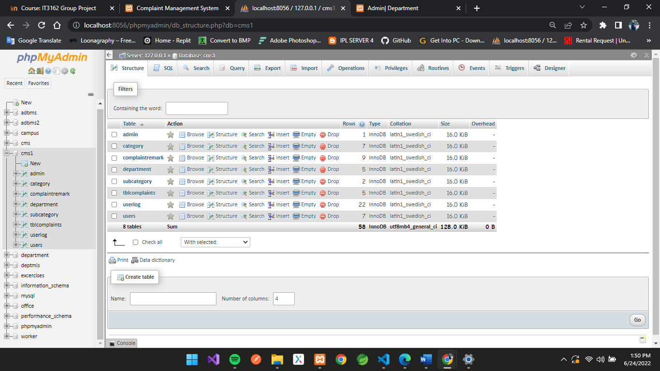

# USER EVALUATION

* **Sampling of Subjects**

Sampling is a Statistic and quantitative research methodology. Since it is generally impossible to study an entire population (every individual in a country, all college students, every geographic area, etc.), researchers typically rely on sampling to acquire a section of the population to perform an experiment or observational study. It is important that the group selected be representative of the population, and not biased in a systematic manner.

There are three main types of Sampling.

1. Simple Random Sampling - Simple random sampling is the basic sampling technique where we select a group of subjects (a sample) for study from a larger group (a population).
2. Stratified Random Sampling - A stratified sample is obtained by taking samples from each stratum or sub-group of a population.
3. Multistage Random Sampling - A multistage random sample is constructed by taking a series of simple random samples in stages

According to this system, it is better to select Stratified Random sampling, because this system may be used in a Complaints management of a university, and that means this system can be handle with a normal IT knowledge person to all the students in a university, because this is client-based system. Selecting different people in different IT knowledge levels is a best way to check the system in various levels of knowledge.

This Sample contain System administrators, normal clients, etc. A different set of clients will give the best result regarding the process of the system some They can checked the system, the algorithms, the flow, and the features.

* **Evaluation Scenarios**

A scenario is a description of a person’s interaction with a system. This interaction is based on different scenarios with the system. These Scenarios describe the process of the system in various levels, in various user angles.

User side Scenarios

* + Login - If the system login with no issues meets the relevant requirements and if the system pops up the needed error messages at the right time.
  + Registration - If the user is new to the system, they have to register first. There is a registration form, which should be filled by the user. Check when the relevant fields in the form pop up the correct messages and when submit it added to the database.

Admin Side Scenarios

* Login- Admin can login with their username and password.
* Requests - Check whether the request count increased when a user made a request. Check whether the admin can check the request and assign the available drivers to the request.

# **TESTING**

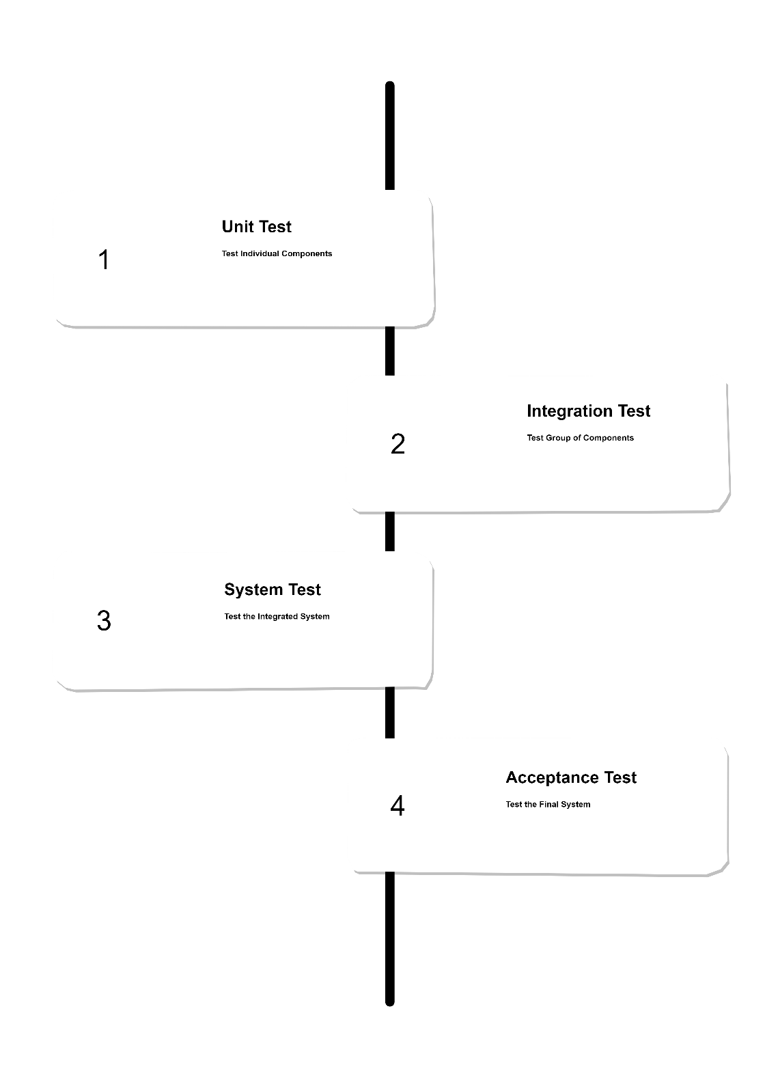

**Test Plan**

The test plan is implemented to plan how to test the system. This system should test unit by unit to check for any bugs or errors. Also, with the result of the Unit Testing, then the Integration test can be implemented or can correct any errors found from Unit testing. Integration test allowed testing the units together. When the integration testing is successful, System test will be implemented to test the complete system. Finally, the Acceptance testing is done by the internal and external volunteers to check whether the system gives the needed requirements to the client.

1. **Unit Testing**

According to the above scenarios following test cases are implemented and

following results gained.

**User side Scenarios**

1. Login

|  |  |  |
| --- | --- | --- |
| **Test cases (input data)** | **Expected result** | **Actual result** |
| Click login button without entering username or password. | Error occurrence:  “Please fill out This Field.”  and user cannot log on to the system | Error occurrence:  “Please fill out This Field.”  and user cannot log on to the system |
| Click login button only entering the username. | Error occurrence:  “Please fill out This Field.”  and user cannot log on to the system. | Error occurrence:  “Please fill out This Field. “  and user cannot log on to the system. |
| Click login button only entering the password. | Error occurrence:  “Please fill out This Field.”  and user cannot log on to the system. | Error occurrence:  “Please fill out This Field.”  and user cannot log on to the system. |
| Click login button entering wrong username and password. | Error occurrence:  “Invalid username or password” and user cannot log on to the system. | Error occurrence:  “Invalid username or password” and user cannot log on to the system. |
| Click login button entering correct username and password. | Successfully login to the system. | Successfully login to the system. |

1. Registration

|  |  |  |
| --- | --- | --- |
| **Test cases (input data)** | **Expected result** | **Actual result** |
| Click Registration button without entering nothing | Error occurrence:  Registration Button Can’t be Clickable. | Error occurrence:  Registration Button Can’t be Clickable. |
| Click Registration button only entering the full name. | Error occurrence:  Registration Button Can’t be Clickable.  and user cannot Register on to the system. | Error occurrence:  Registration Button Can’t be Clickable.  and user cannot Register on to the system. |
| Click Registration button only entering the password. | Error occurrence:  Registration Button Can’t be Clickable.  and user cannot Register on to the system. | Error occurrence:  Registration Button Can’t be Clickable.  and user cannot Register on to the system. |
| Click Registration button entering contact No | Error occurrence:  Registration Button Can’t be Clickable.  and user cannot Register on to the system. | Error occurrence:  Registration Button Can’t be Clickable.  and user cannot Register on to the system. |
| Click Registration button entering Full name and password. | Error occurrence:  Registration Button Can’t be Clickable.  and user cannot Register on to the system. | Error occurrence:  Registration Button Can’t be Clickable.  and user cannot Register on to the system. |
| Click Registration button entering Full name, contact No and password. | Error occurrence:  Registration Button Can’t be Clickable.  and user cannot Register on to the system. | Error occurrence:  Registration Button Can’t be Clickable.  and user cannot Register on to the system. |
| Entered an email address with wrong validations.  Ex: x | Error occurrence:  Please include an ‘@’ in the email address.  and user cannot Register on to the system. | Error occurrence:  Please include an ‘@’ in the email address.  and user cannot Register on to the system. |
| Entered an email address with wrong validations.  Ex: x@ | Error occurrence:  Please enter a part following ‘@’  and user cannot Register on to the system. | Error occurrence:  Please enter a part following ‘@’  and user cannot Register on to the system. |
| Entered an email address with validations.  Ex: x@gamil.com | Message Shown:  Email Available for Registration.  and user cannot Register on to the system. | Message Shown:  Email Available for Registration.  and user cannot Register on to the system. |
| Click Registration button entering Full name, email and password. | Error occurrence:  “Please fill out This Field.”  and user cannot Register on to the system. | Error occurrence:  “Please fill out This Field.”  and user cannot Register on to the system. |
| Click Registration button entering Full name, already exist email, contact No and password. | Message Shown:  Email Already Exist.  and user cannot Register on to the system. | Message Shown:  Email Already Exist.  and user cannot Register on to the system. |
| Click Registration button entering Full name, email, contact No and password. | Successfully Registered and Message shown:  “Registration Successful. Now You can Login!” | Successfully Registered and Message shown:  “Registration Successful. Now You can Login!” |

1. **Integration Testing**

System is tested with the database. The details entered to the system and details retrieved from the database to the system are tested top to bottom and bottom to top.

**User scenario:**

|  |  |  |
| --- | --- | --- |
| **Test cases** | **Expected result** | **Actual result** |
| Click on Register button after filling the form. | Database updated with a new user each time. | Database updated with a new user each time. |
| Login with the username and password. | Check with the user details and if correct logged in otherwise pop up an error. | Check with the user details and if correct logged in otherwise pop up an error. |
| Complaint Form | Select an item from the list that already uploaded in Database and also fill the form without error then form update a complaint in database. | Select an item from the list that already uploaded in Database and also fill the form without error then form update a complaint in database. |
| Complaint History | Watch your Complaints that already Submitted that Retrieved from database. | Watch your Complaints that already Submitted that Retrieved from database. |
| Profile Setting | Update your user profile with picture and other details, then it updated in the database. | Update your user profile with picture and other details, then it updated in the database. |

**Admin scenario:**

|  |  |  |
| --- | --- | --- |
| **Test cases** | **Expected result** | **Actual result** |
| View Complaints | Retrieved data from database and shown in a system. | Retrieved data from database and shown in a system. |
| Manage Complaints | View and take action for the complaints that retrieved from database. | View and take action for the complaints that retrieved from database. |
| Action form | Select status and remarked and submitted then updated in a database. | Select status and remarked and submitted then updated in a database. |
| View user details | Watch your users that Retrieved from database and able to delete users. | Watch your users that Retrieved from database and able to delete users. |
| Add fields | Update fields in complaint form that updated in database. | Update fields in complaint form that updated in database. |

1. **System Testing**

After successfully finishing the unit and integration testing the system is all together tested. This testing will be done by the developers their selves to check the system, if it meets the requirements. As the unit testing and integration testing was successful, the system testing also successful.

1. **Acceptance Testing**

Formal testing with respect to user needs, requirements, and business processes conducted to determine whether or not a system satisfies the acceptance criteria and to enable the user, customers or other authorized entity to determine whether or not to accept the system.

Acceptance testing is done through two stages:

* **Internal Acceptance Testing**-Done by the members of the Organization who developed the

system, but not who involved in the development.

* **External Acceptance Testing**-Done by the outside users.

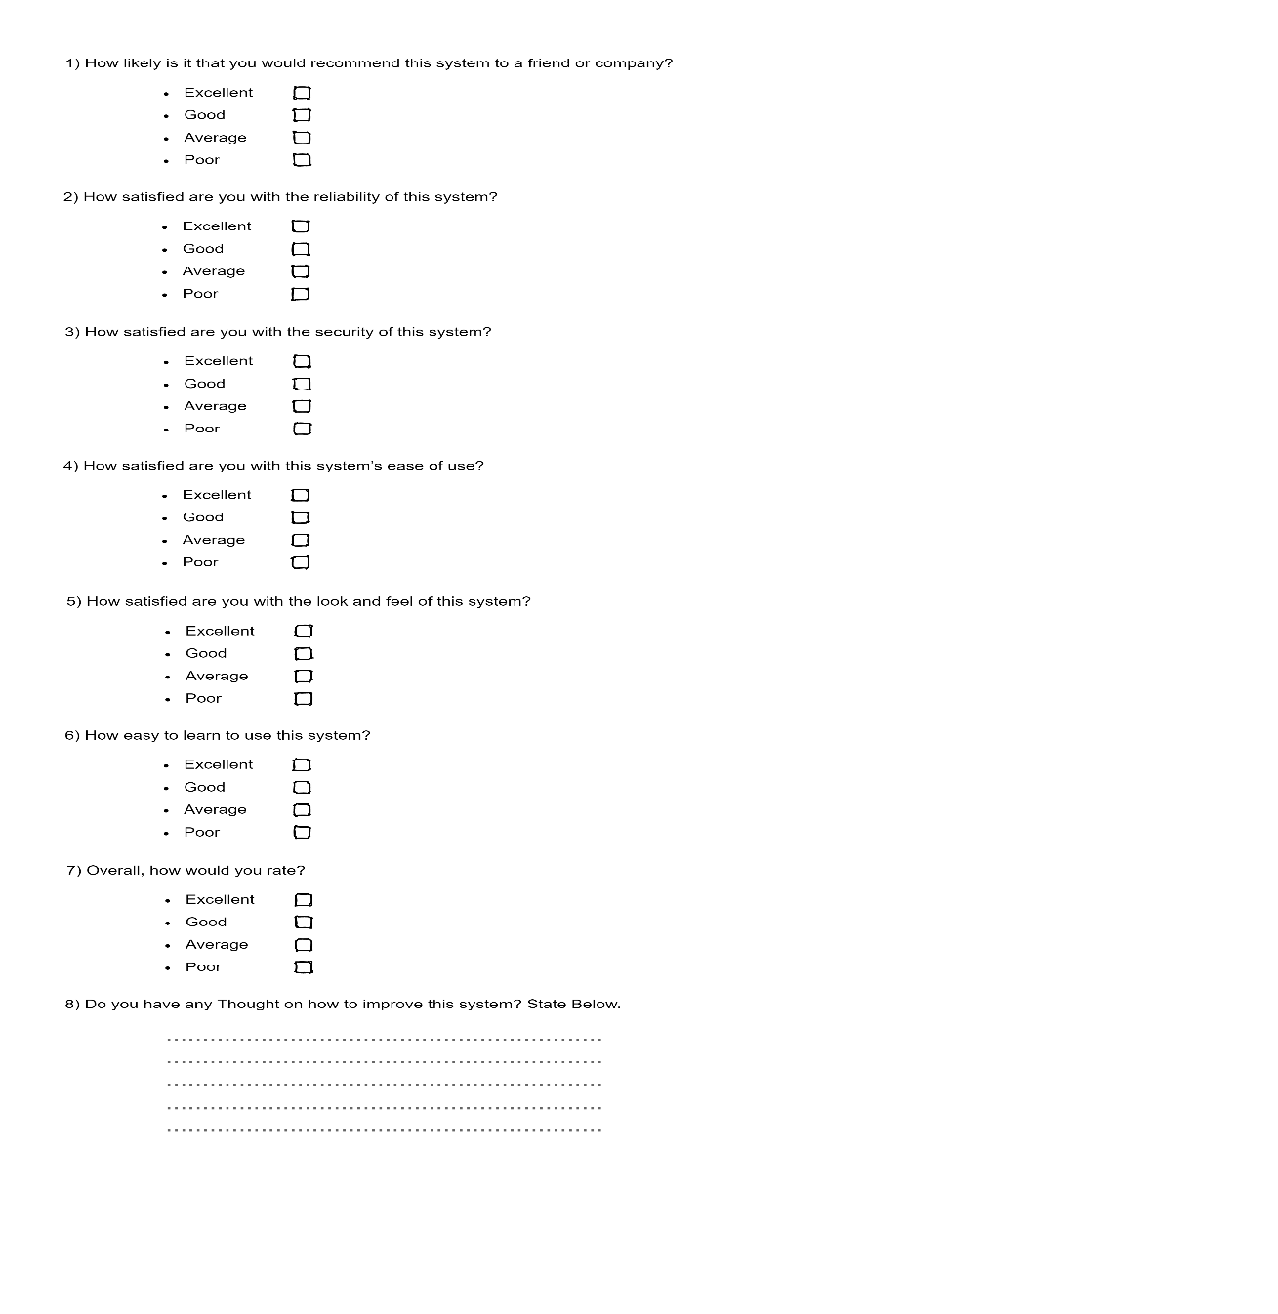

**Questionnaire Form**

# **TEST REPORTS**

The overall results of the Acceptance Test are as follow:

# **CONCLUSION**

Complaints lodged range from Academic, Administrative, social and other issues relating to the student and the academic and non-academic staff. This platform allows for complaints to be lodged remotely by students with issues relating to their registration, examination, examination result and hall of residence complaints and thereby enhances the response time for the appropriate unit to resolve the addressed complaints. And also, can lodge complains about canteen and other issues also.

The system will empower the upgrade, recovery, erasure and era of request report as indicated by the degree and arrangement of academic environment.

Lessons Learnt

• Studied how to plan the work of the system

• Time Management

• Learn how to change the system according to others comments

Achievement of Objectives

• Web app for the Client side built.

• Web app for the admin side built

• Client can login using Website.

• Client can lodge any complaint using Website

• Admin can check the newly lodged complaints through Website.

• Admin can generate reports

• Admin can query the database.

• Admin get an alert about the lodged complaints.

# **FUTURE IDEAS**

• We can implement our webapp into mobile app. This will reach very efficiently among the users.

• Will update the features more interactive with the users.

• If any complain is needed to solve by the UGC, can implement the app by give an admin to the UGC and they can monitor the complaints.

• Provide the portal to not only other universities also other private sectors and organizations.

# **REFERENCES**

[https://www.modishproject.com/students-complaints-management-system/.](https://www.modishproject.com/students-complaints-management-system/)

Dec 21 2021

<https://www.waterintegritynetwork.net/2015/12/03/customer-complaint>

Dec 29 2021

[https://www.waterintegritynetwork.net/2015/12/03/customer-complaint-managementmanagement/.](https://www.waterintegritynetwork.net/2015/12/03/customer-complaint-managementmanagement/.%20)

Jan 01 2022

[https://policy.usq.edu.au/documents/141630PL/.](https://policy.usq.edu.au/documents/141630PL/.%20)

Feb 14 2022